**YEAR 10 DIET, DRUGS AND NUTRITION**

**ENERGY INPUT AND ENERGY OUTPUT ASSESSMENT**



/45

%

**Name: ________________________________________________**

**Form: ____________________________**

**Part 1 - Energy in**

After learning about food consumption and energy input, it’s time to determine how much energy you are putting into **your** system. You will complete a food log, in which you will record **ALL** the food consumed on a particular day of your choice, including **breakfast, lunch, dinner and any additional snacks.**

You must also record **ONE** meal **every day** (**either** breakfast, lunch, dinner or a combination of your snacks) for the whole week.

You will record all the information in the tables below, or in a format of your choice. To achieve full marks, you must also complete the questions that follow the food log. **YOU WILL NEED TO USE THE FOOD CHART ATTACHED ON THE LAST PAGE TO ASSIST YOU WITH KILOJOULES PER FOOD QUANTITY.**

**DETAILED FOOD LOG:**

**DAY/DATE:____________________________________________________________**

(4 marks)

|  |  |  |  |
| --- | --- | --- | --- |
| **MEAL** | **FOODS EATEN** | **TOTAL QUANTITY OF FOOD** | **KILOJOULES** |
| **BREAKFAST** |  |  |  |
| **LUNCH** |  |  |  |
| **DINNER** |  |  |  |
| **SNACKS** |  |  |  |

**WEEKLY FOOD LOG:**

(10.5 marks)

|  |  |  |  |  |
| --- | --- | --- | --- | --- |
| **DAY** | **MEAL** | **FOODS EATEN** | **QUANTITY OF FOOD** | **KILOJOULES** |
| **MONDAY** |  |  |  |  |
| **TUESDAY** |  |  |  |  |
| **WEDNESDAY** |  |  |  |  |
| **THURSDAY** |  |  |  |  |
| **FRIDAY** |  |  |  |  |
| **SATURDAY** |  |  |  |  |
| **SUNDAY** |  |  |  |  |

**QUESTIONS:**

(2 marks)

1. What is your recommended daily kilojoule intake? (note: refer to the PowerPoint from week 1, you will need to convert calories to kilojoules – show working!!)

____________________________________________________________________________________________________________________________________________________________________________________________________________________________________________________________________________________________________________

(2 marks)

1. Calculate your total kilojoule intake for your selected day (show working!!)

____________________________________________________________________________________________________________________________________________________________________________________________________________________________________________________________________________________________________________

1. Were you above or below your daily recommended kilojoule intake? Discuss what food groups you could focus on reducing or increasing. Explain why you chose these particular foods.

(2 marks)

__________________________________________________________________________________________________________________________________________________________________________________________________________________________________________________________________________________________________________________________________________________________________________________________________________________________________________________________________



**Part 2 - Energy out**

After learning about exercise and energy expenditure, it’s time to determine how much energy you are taking out of your system. You will complete an exercise log where you will record **ALL** the exercise conducted on a particular day of your choice.

To accompany the detailed exercise log, you are also required to record **ONE** form of exercise conducted each day, for the whole week.

You will record all the information in the tables below, or in a format of your choice. To attain full marks, you must also complete the questions that follow the exercise log. **YOU WILL NEED TO USE THE EXERCISE CHART USED IN THE WEEK 2 POWERPOINT (ENERGY BALANCE) TO ASSIST YOU WITH KILOJOULES EXPENDED IN EXERCISE.**

PLEASE TRY TO INCLUDE AS MANY EXERCISES AS POSSIBLE TO GAIN THE MOST ACCURATE RESULTS ON HOW MUCH ENERGY YOU ARE BURNING – EVEN MESSAGING SOMEONE ON YOUR PHONE COUNTS!!

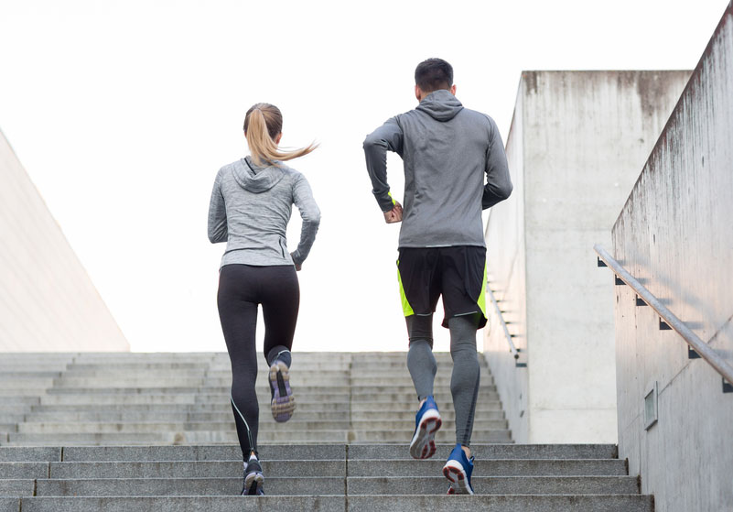

**DETAILED EXERCISE LOG:**

**DAY/DATE:____________________________________________________________**

(4.5 marks)

|  |  |  |  |
| --- | --- | --- | --- |
| **TIME OF DAY** | **EXERCISES COMPLETED** | **EXERCISE DURATIONS** | **KILOJOULES EXPENDED** |
| **MORNING** |  |  |  |
| **AFTERNOON** |  |  |  |
| **EVENING** |  |  |  |

**WEEKLY EXERCISE LOG OF ONE EXERCISE PER DAY:**

(14 marks)

|  |  |  |  |  |
| --- | --- | --- | --- | --- |
| **DAY** | **EXERCISES COMPLETED** | **EXERCISE DURATION** | **INTENSITY OF EXERCISE** | **KILOJOULES EXPENDED** |
| **MONDAY** |  |  |  |  |
| **TUESDAY** |  |  |  |  |
| **WEDNESDAY** |  |  |  |  |
| **THURSDAY** |  |  |  |  |
| **FRIDAY** |  |  |  |  |
| **SATURDAY** |  |  |  |  |
| **SUNDAY** |  |  |  |  |

**QUESTIONS:**

(2 marks)

1. Calculate your total kilojoule expenditure for your selected day (show working!!)

_________________________________________________________________________________________________________________________________________________________________________________________________________________________________

(2 marks)

1. Were you over your daily recommended kilojoule expenditure, or were you below? Discuss what exercises (or exercise durations) you could focus on increasing or reducing. Explain why you chose these exercises.

________________________________________________________________________________________________________________________________________________________________________________________________________________________________________________________________________________________________________

(2 marks)

1. Compare your results from your detailed food log against your detailed exercise log. Did you add extra energy to your body or did you expend additional energy? Discuss why you think you either added or expended energy.

____________________________________________________________________________________________________________________________________________________________________________________________________________________________________________________________________________________________________________

**END OF ASSIGNMENT!**

